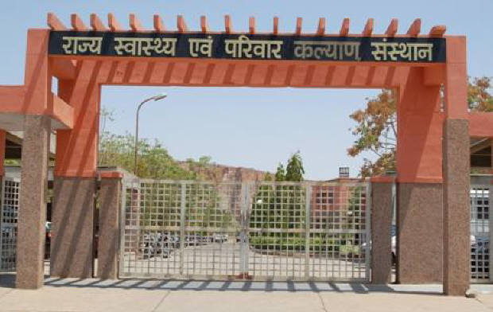
SIHFW Rajasthan

Electronic Newsletter 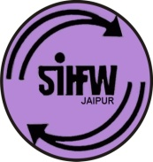
Ed. 2022-23 E-1 (January to March 2022 Issue)
SIHFW: an ISO 9001:2015 certified Institution
From the Director’s desk…

Dear Friends…

Greetings from SIHFW!!

This issue of newsletter is for January to March 2022, during this period, SIHFW team celebrated Republic day on 26th January. This duration also has a very important day ie; World Tuberculosis Day on March 24, 2022. Theme of this year World TB day is “Invest to End TB, Save lives”. It conveys urgent need to invest resources to rampo up the fight against TB to achieve commitments to end TB by global leadership. Therefore, we have included an article on ‘Tuberculosis’ in this newsletter. It gives information on the disease, its treatment and government programmes to control the disease. The newsletter also contains information on other activites done by SIHFW during this period.
We would solicit your feedback and suggestions.

Best Wishes!!
Dr. R.P. Doria
Director-SIHFW
_____________________________________________________________
Some important health and social days
January 1: World Day for Peace | March 1: Colorectal Cancer Awareness Month
January 27: World Leprosy Day | March 8: International Women’s Day
February 1-28: Healthy Lifestyle Awareness Month | March 13: World Sleep Day
February 4: World Cancer Day | March 20: International Day of Happiness
February 12: World Epilepsy Day | March 21: World Down Syndrome Day
February 15: International Childhood Cancer Day | March 22: World Water Day
February 24: World Sustainable Energy Day | March 23; World Meteriological Day
March 1-31: Tuberculosis (TB) Awareness Month | March 24: World Tuberculosis Day
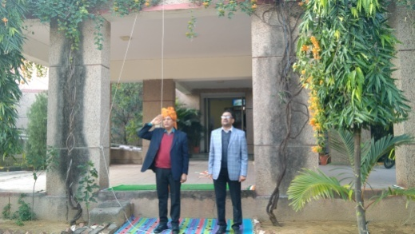
SIHFW Staff team celebrated 73rd Republic Day, 26 January 2022 at SIHFW, flag hoisting was done by Director SIHFW.

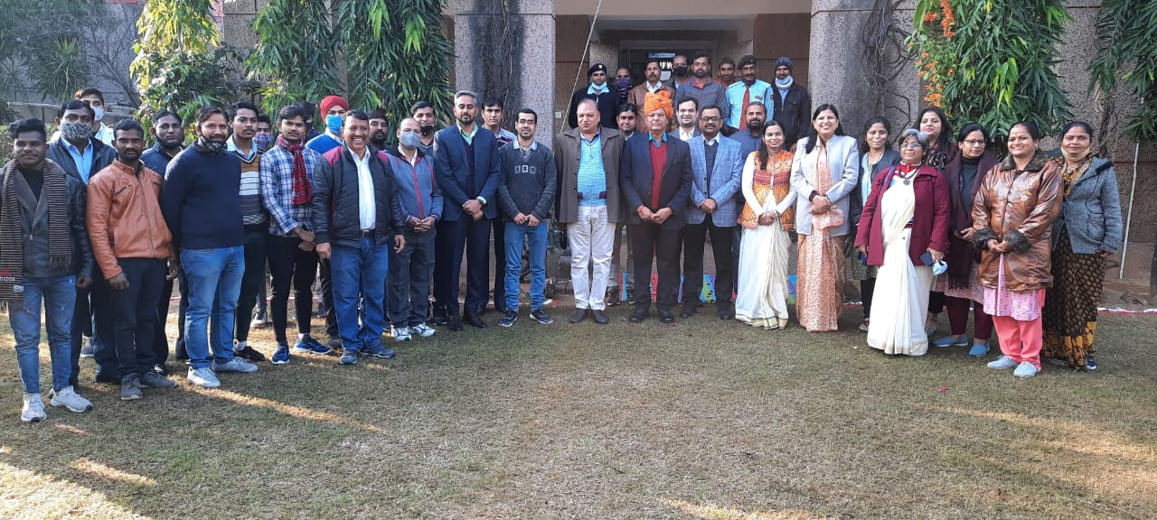

Tuberculosis
About the disease:
Tuberculosis (TB) is caused by bacteria (Mycobacterium tuberculosis) that most often affect the lungs. Tuberculosis is curable and preventable. TB is spread from person to person through the air. When people with lung TB cough, sneeze or spit, they propel the TB germs into the air. A person needs to inhale only a few of these germs to become infected.
Key facts:
- A total of 1.5 million people died from TB in 2020 (including 214 000 people with HIV). Worldwide, TB is the 13th leading cause of death and the second leading infectious killer after COVID-19 (above HIV/AIDS).
- An estimated 66 million lives were saved through TB diagnosis and treatment between 2000 and 2020.
- Globally, TB incidence is falling at about 2% per year and between 2015 and 2020 the cumulative reduction was 11%. This was over half way to the End TB Strategy milestone of 20% reduction between 2015 and 2020.
- Ending the TB epidemic by 2030 is among the health targets of the United Nations Sustainable Development Goals (SDGs).
- Contacts of an active case are at 10 to 60 times higher risk of developing the disease

About one-quarter of the world's population has TB infection, which means people have been infected by TB bacteria but are not (yet) ill with the disease and cannot transmit it. People infected with TB bacteria have a 5–10% lifetime risk of falling ill with TB. Those with compromised immune systems, such as people living with HIV, malnutrition or diabetes, or people who use tobacco, have a higher risk of falling ill.
When a person develops active TB disease, the symptoms (such as cough, fever, night sweats, or weight loss) may be mild for many months. This can lead to delays in seeking care, and results in transmission of the bacteria to others. People with active TB can infect 5–15 other people through close contact over the course of a year. Without proper treatment, 45% of HIV-negative people with TB on average and nearly all HIV-positive people with TB will die.

Global impact of TB
TB occurs in every part of the world. In 2020, the largest number of new TB cases occurred in the WHO South-East Asian Region, with 43% of new cases, followed by the WHO African Region, with 25% of new cases and the WHO Western Pacific with 18%.
In 2020, 86% of new TB cases occurred in the 30 high TB burden countries. Eight countries accounted for two thirds of the new TB cases: India, China, Indonesia, the Philippines, Pakistan, Nigeria, Bangladesh and South Africa.

Symptoms and diagnosis
Common symptoms of active lung TB are cough with sputum and blood at times, chest pains, weakness, weight loss, fever and night sweats. WHO recommends the use of rapid molecular diagnostic tests as the initial diagnostic test in all persons with signs and symptoms of TB as they have high diagnostic accuracy and will lead to major improvements in the early detection of TB and drug-resistant TB. Rapid tests recommended by WHO are the Xpert MTB/RIF Ultra and Truenat assays.
Diagnosing multidrug-resistant and other resistant forms of TB (see Multidrug-resistant TB section below) as well as HIV-associated TB can be complex and expensive. Tuberculosis is particularly difficult to diagnose in children.

Treatment
TB is a treatable and curable disease. Active, drug-susceptible TB disease is treated with a standard 6-month course of 4 antimicrobial drugs that are provided with information and support to the patient by a health worker or trained volunteer. Without such support, treatment adherence is more difficult. Since 2000, an estimated 66 million lives were saved through TB diagnosis and treatment.

TB and HIV

Who is most at risk?
- Tuberculosis mostly affects adults in their most productive years. However, all age groups are at risk.
- Over 95% of cases and deaths are in developing countries.
- People who are infected with HIV are 18 times more likely to develop active TB
- The risk of active TB is also greater in persons suffering from other conditions that impair the immune system.
- People with undernutrition are 3 times more at risk. Globally in 2020, there were 1.9 million new TB cases that were attributable to undernutrition.
- Alcohol use disorder and tobacco smoking increase the risk of TB disease by a factor of 3.3 and 1.6, respectively.
- In 2020, 0.74 million new TB cases worldwide were attributable to alcohol use disorder and 0.73 million were attributable to smoking.

People living with HIV are 18 times (Uncertainty interval: 15-21) more likely to develop active TB disease than people without HIV.
HIV and TB form a lethal combination, each speeding the other's progress. In 2020, about 215 000 people died of HIV-associated TB. The percentage of notified TB patients who had a documented HIV test result in 2020 was only 73%, up from 70% in 2019. In the WHO African Region, where the burden of HIV-associated TB is highest, 85% of TB patients had a documented HIV test result. Overall in 2020, 88% of TB patients known to be living with HIV were on ART. WHO recommends a 12-component approach of collaborative TB-HIV activities, including actions for prevention and treatment of infection and disease, to reduce deaths.

Multidrug-resistant TB
Anti-TB medicines have been used for decades and strains that are resistant to one or more of the medicines have been documented in every country surveyed. Drug resistance emerges when anti-TB medicines are used inappropriately, through incorrect prescription by health care providers, poor quality drugs, and patients stopping treatment prematurely.
Multidrug-resistant tuberculosis (MDR-TB) is a form of TB caused by bacteria that do not respond to isoniazid and rifampicin, the 2 most effective first-line anti-TB drugs. MDR-TB is treatable and curable by using second-line drugs. However, second-line treatment options are limited and require extensive chemotherapy (up to 2 years of treatment) with medicines that are expensive and toxic. In some cases, more severe drug resistance can develop. TB caused by bacteria that do not respond to the most effective second-line anti-TB drugs can leave patients without any further treatment options.
MDR-TB remains a public health crisis and a health security threat. Only about one in three people with drug resistant TB accessed treatment in 2020.
Worldwide in 2018, the treatment success rate of MDR/RR TB patients was 59%. In 2020, WHO recommended a new shorter (9-11 months) and fully-oral regimen for patients with MDB-TB. This research has shown that patients find it easier to complete the regimen, compared with the longer regimens that last up to 20 months. Resistance to fluoroquinolones should be excluded prior to the initiation of treatment with this regimen.
In accordance with WHO guidelines, detection of MDR/RR-TB requires bacteriological confirmation of TB and testing for drug resistance using rapid molecular tests, culture methods or sequencing technologies. Treatment requires a course of second-line drugs for at least 9 months and up to 20 months, supported by counselling and monitoring for adverse events. WHO recommends expanded access to all-oral regimens.
TB Diseases Burden in India
Despite the brief decline in TB notifications observed around the months corresponding to India’s two major COVID-19 waves, the National Tuberculosis Elimination Programme (NTEP) reclaimed these numbers. Accordingly, 2021 witnessed a 19% increase from the previous year in TB patients’ notification—the total number of incident TB patients (new and relapse) notified during 2021 were 19,33,381 as opposed to that of 16,28,161 in 2020. In 2021, the vision of the National Strategic Plan for Elimination of Tuberculosis (NSP 2017- 25) permeated to state and district levels yet again to encompass more objectives. Eighteen States have committed to Ending TB by 2025 by formally implementing Statespecific Strategic Plans and have gone a step ahead to devise a District-specific Strategic Plan, which shall serve as a guiding tool for the programme managers and staff at the district and sub-district level towards the elimination of Tuberculosis

Estimates of the burden of disease caused by TB measured in terms of incidence, prevalence and mortality are produced annually by WHO using information gathered through surveillance systems (patient notifications and death registrations), special studies (including surveys of the prevalence of disease), mortality surveys, inventory studies of under-reporting of detected TB, in-depth analysis of surveillance and other data, expert opinion and consultations with countries.

TB Incidence

As per the Global TB Report 2021, the estimated incidence of all forms of TB in India for the year 2020 was 188 per 100,000 population (129-257 per 100,000 population).

The total number of incident TB patients (new & relapse) notified during 2021 was 19,33,381 which was 19% higher than that of 2020 (16,28,161). The programme had been able to catch-up with the dip in TB notifications that was observed around the months when the two major covid waves happened in India. Though factors such as changes in the health seeking behaviour of patients with chest symptoms (patien t-related) as well as diversion of the human and material resources (provider-related) were seen across the country, NTEP has been resilient in regaining the momentum of finding the missing TB patients by introducing bidirectional screening for TB-Covid, doorstep delivery of services as well as earned gains on the behaviour change of people in terms of respiratory etiquette, which in the long run is expected to have an impact on reducing the transmission of TB as well as other respiratory infections within the community.
Scenario in India
- Estimated incidence rate of TB = 193 cases / lakh population
- Estimated TB cases in 2019 in India = 26.4 lakh
- Reported TB cases = 24 lakh (2019) = 18 lakh (2020) = 12.8 lakhs (So far-Aug’21)

Global TB Burden -2021

 | Global | India | Global (%)
Incidence | 98.7 lac (127/lac) | 25.9 lac (188/lac) | 26%
HIV-Negative TB Mortality | 12.8 lac (17/lac) | 4.93 lac (36/lac) | 38%
HIV-Positive TB Mortality | 2.14. lac (2.7/lac) | 0.11 lac (0.78/lac) | 5%
HIV TB cases | 7.87 lac (10/lac) | 0.53 lac (3.8/lac) | 7%
Source: India TB report, 2021

Childhood Tuberculosis
Trend of Paediatric TB Notification:
Years | Paediatric TB Cases Notified | % among Total TB Cases
2012 | 81482 | 7
2013 | 63884 | 5
2014 | 72307 | 6
2015 | 75083 | 5
2016 | 76475 | 5
2017 | 109678 | 6
2018 | 129896 | 6
2019 | 151053 | 8
2020 | 102489 | 6
2021 | 118232 | 6
Source: India TB Report 2022

Tuberculosis remains a major cause of morbidity and death from infectious diseases for children of all ages globally, particularly in young children. As per the Global TB Report 2021, about 3.06 lakh children (0-14 years of age) are estimated to get TB every year, accounting for about 11 % of total estimated TB cases reported to the NTEP. In India, childhood Tuberculosis is a staggering problem, contributing to approximately 31% of the global burden.

However, over the last decade, consistently, children constitute 6-7% of all the patients treated under NTEP annually, pointing to a gap of 4-5% of total notification against the estimated incidence. Inarguably, the case reporting across the states varies and is attributed to differences in the burden of disease, health-seeking behaviour, and accessibility to services.

Paediatric Drug-Resistant Tuberculosis
The dearth of paediatric DR-TB data remains a challenge both globally and nationally. Only 12,200 (11%) of the target of 1,15000 was achieved globally for the pediatric age group. MDR-TB in children reflects MDR-TB in adults and, therefore, is common in settings where the MDR-TB pool exists in adults.
Transmission of DR-TB in children is mainly from the close contact of a confirmed MDR-TB patient (usually an adult or adolescent) and less commonly through previously inadequate TB treatment.
To build pediatricians’ capacity in the public and private sectors, Continued Medical Education (CME) and training workshops are being conducted by Indian Asociation of Pediatrics (IAP). To date, more than 4500 doctors have been trained virtually/physically.

To address the common diagnostic challenges in paediatric TB, including DR-TB, NTEP has mandated upfront molecular diagnostics for all paediatric TB samples. The programme has child-friendly formulations of drugs for the management of paediatric drug-sensitive TB and is procuring child-friendly formulations for DR TB. Bedaquiline is approved for use in children above five years of age. NTEP has acquired the 20mg dispersible tab of Bedaquiline through the Japanese Grant of STOP TB Partnership.

TB and Pregnancy

While the burden of TB is higher in men in India, the impact of TB in women is far-reaching, especially for women in the reproductive age group (15-49 years). Due to common nonspecific symptoms in both TB and pregnancy, diagnosing TB disease in pregnant women is complex. TB in pregnancy has a wide spectrum of short and long-term implications and could have sequential effects: repeated reproductive failure, fetal ill-health, preterm delivery, and TB of the new-borns and infants, leading to high maternal and perinatal morbidity and mortality. For example, there is a six-fold increase in perinatal deaths and a two-fold risk of premature birth and low birth weight in mothers with active TB disease.

The NTEP and the Maternal Health (MH) division has developed a Collaborative Framework for Management of TB in Pregnant Women to reduce morbidity and mortality due to TB in pregnant women and new-borns through prevention, screening for early detection, and prompt management of TB in pregnant women and achieve optimum maternal and perinatal outcomes. This screening for TB will be made an essential component of ANC services. The National-level sensitisation workshop for all the state nodal officers of both the programmes has been conducted, and the training will be cascaded. In 2021, the number of female patients screened for pregnancy was 47185, out of which 4048 were pregnant (Public - 3237, Private - 811).

National TB Elimination Programme (NTEP)

The NTEP is the Public Health initiative of the Government of India that organizes its anti-Tuberculosis efforts. It functions as a flagship component of the National Health Mission (NHM) and provides technical and managerial leadership to anti-tuberculosis activities in the country. Programme was able to notify 21 lakh TB patients including 6.68 TB patients through the private sector.

Evolution of NTEP
Year | Milestones
1962 | Govt of India launched the National TB program and set up District TB centres
1993 | WHO declared TB as a Global disease
1997 | GoI revised NTP to RNTCP – introduction of DOTS (Directly Observed Treatment Short course)
2005 – 11 | Second phase of RNTCP – Pan India coverage and improved quality and scale up of services
2012 -17 | National Strategic Plan (2012 -17) - mandatory notification of TB, rapid molecular testing, active case finding and integration of the program with National Health Mission
2017 – 25 | NSP (2017 – 25) – patient centric care for TB elimination
2020 | In January 2020, GoI revised RNTCP to National TB Elimination Program (NTEP)
2021 | TB Mukt Bharat Abhiyaan

Vision for freedom from TB

Scenario | 2021-23 | 2024-25 (Projected SDG Scenario) SDG population prevention and Infection control
Presumptive TB Examination rate / lakh/Population per year | 1800 | 2400
Notification / Estimates | 100% | 100%
LTBI (% coverage of targeted population) | 70% | 90%
PPSA (districts with interface agencies for private sector engagement) | 400 | 600

NATIONAL STRATEGIC PLAN (2017-2025)

- Find all TB cases with an emphasis on reaching every TB patient in the private sector
- Treat all TB cases with high quality anti TB drugs
- Prevent the emergence of TB in susceptible populations and stop catastrophic expenditure due to TB by all
- Build & strengthen supportive systems including enabling policies, empowered institutions & human resources

Detect | - Decentralize TB screening to AB-HWC levels  - Scale up Molecular Diagnostics to the Peripheral Levels  - Early Detection of DRTBUniversal DST  - Vulnerability Mapping & Active case finding  - Private Sector Engagement
Treat | - Daily regimen –Fixed Dose Combination  - Sustain Treatment Success Rate of > 90%  - Injection free treatment regimens  - Scale up of Newer drugs/regimens
Prevent | - Sustaining COVID appropriate behaviour  - Contact Tracing & TB Preventive Treatment  - Airborne Infection Control in community & Health Facilities  - Community Mobilization & People’s Movement
Build | - IEC  - Capacity Building  - Human Resources Development  - Multisectoral Collaboration  - Digital Interventions  - Surveillance  - Procurement & Supply Chain Management

NIKSHAY Poshan
•Rs. 500/- per month given to every TB patient through DBT for duration of treatment
•Scheme rolled out from April 2018
•Rs. 1204 Cr of amount disbursed to beneficiaries

Mechanisms for Monitoring and Evaluation
Internal | External
• Quarterly Review meeting at National, State and District levels  • Central & State Internal Evaluations  • External and Internal Quality assessment of labs by IRLs and NRLs  • Annual Common Review Mission as part of NHM • Sub National TB free certification | • State Health Index report by NITI Aayog (Annual) •World Bank review mission (6 monthly)  •Joint monitoring mission by WHO (once in 3 years)

National Policy for Diagnosis

Drug-Sensitive TB (DS TB)
- Patients with Pulmonary TB are diagnosed using sputum smear microscopy/ Chest- X ray and NAAT (Nucleic Acid Amplification Tests). Smear replacement by NAAT and offer of upfront NAAT for diagnosis of TB has been prioritized by the Programme.
- Response to DS TB treatment is monitored using sputum smear microscopy.

Drug-Resistant TB (DR TB)
- Microbiologically confirmed TB patients are offered NAAT for determining resistance to Rifampicin.
- Line Probe Assay (LPA – First Line) is offered to patients with Rifampicin Sensitive (RS) TB.
- First and Second Line LPA is offered to Rifampicin-resistant (RR) and Isoniazid (H) resistant TB patients. Liquid Culture (LC) & DST is performed for determining amplification of resistance to drugs used for managing DR TB.
- LC is used for monitoring response to DR TB treatment.

Case finding strategies
Passive Case Finding | Intensified Case Finding | Active Case Finding
Patients with symptoms of TB voluntarily seek health care. | This is a provider-initiated screening of outpatient clinic/hospital attendees for symptoms of TB. | Actively searching for TB patients among poulation at higher risk of TB in the community.
The Medical Officer follows diagnostic algorithm for for evaluating TB patients. | TB screening for patients attending health facilities with comorbidities.

TB Laboratory Network in NTEP in 2021

Microscopy,
NAAT,
LPA,
Liquid Culture,
LCDST

21820 DMCs

58
3960 NAAT
District and Sub District Level

C&DST Laboratory (In Medical Colleges and Private Sector)

Intermediate Reference Laboraotory (State Level)

- Microscopy
- Rapid Molecular Test (NAAT)

- CBNAAT
- TrueNAT

Peripheral Sub District Level

NAAT‐ Nucelic Acid Amplification Test;
LPA‐ Line Probe Assay;
LC DST‐ Liquid Culture Drug Susceptibility Testing
Patient Support Systems

Direct Benefit Transfer (DBT) to beneficiaries is a novel initiative by the Government of India, enabling targeted delivery of benefits to citizens directly to the bank account(s), thus enhancing efficiency, effectiveness, transparency, and accountability for each transaction. Under the National TB Elimination Programme following schemes are currently ongoing:
- Nikshay Poshan Yojana (NPY)
- Transport support for TB patients in notified tribal areas
- Honorarium for Treatment Supporters
- Notification & Treatment Outcome Incentive for Private Sector Providers
The Government of India launched the Nikshay Poshan Yojna (NPY) scheme in April 2018, providing financial incentives via DBT to all TB patients to support their nutritional requirements for the duration of their treatment. Furthermore, under the Tribal Support Scheme, a one-time financial incentive of Rs 750 is provided to the notified TB patients residing in tribal areas. In addition, Treatment Supporters are provided an honorarium for supporting notified TB patients successfully complete their treatment. Similarly, private providers are also provided financial incentives for both notifying a TB patient as well as reporting their treatment outcome.

Schemes | Beneficiary | Benefit Amount
Nikshay Poshan Yojana (NPY) | - Confirmed TB Patients  - DSTB & DRTB  - Public + Private Sector Patients | Rs 500 per month
Tribal Support Scheme | Confirmed TB Patients residing in Tribal TU | Rs 750 (one time)
Treatment Supporter Honorarium | Treatment Supporter | - Rs 1,000 for DS TB patients  - Rs 5,000 for DR TB patients
Incentive for Notification and Outcomes | Private Health Facilities:  • Practitioner / Clinic etc. (Single)  • Hospital/ Clinic/ Nursing Home etc. (Multi)  • Laboratories Chemists | - Rs 500 as Informant or Notification Incentive  - Rs. 500 for Outcome declaration

Scenario in Rajasthan

Infrastructure in Rajasthan:

Facility | Available
State TB control Cell | 1 at DMHS
State TB Demonstration and Training Centre | 1 at Ajmer
District TB control Units | 34(2 in jaipur and 1 each in other districts)
TB Units | 283 (1 in general plain area at 1.5 to 2.5 lakh population and 1 in Desert and Tribal area on population of 50,000)
Microscopy Centre | 848 (1 each in plain area on 1 lakh population and 1 in desert and tribal area on population of 50,000)
Culture/ DST Lab First Line | - IRL Lab, State TB Demonstration and Training Centre, Ajmer  - Microbiology Lab, SMS Medical college, Jaipur  - Microbiology Lab, SN Medical College, Jodhpur
Treatment centres, DOT Centre | More than 2000
Sub Centre-Treatment Observation Points | More than 15000 (1 on per 3000 to 5000 population area)
Culture/ DST Lab Second Line | 1 Microbiology Lab, SMS Medical college, Jaipur
Gene Expert Lab | 60
Nodal DRTB Centres | 7

Partnership with Private Sector

Private Service providers are provided Rs 500/- on first time notification of private doctors. 23 NGOs and 148 private doctors have been partnered under partnership Guideline, 2014.

CB NAAT Machine
This machine helps in diagnosis of TB with in 2 hours. 66 machines (Gene expert machines) have been installed in Rajasthan. Private doctors can also use these machines free of cost in diagnosis of patients getting treated from private doctors. There are 69 TRUNAT machine also.

Programmatic Management of Drug resistant Tuberculosis (PMDT guidelines)

7 DRTB centres have been upgraded to Nodal DRTB centres. DRTB centres, with facility of indoor treatment and management of general adverse effects have been established in all districts. Shorter MDR Regimen has been established in Rajasthan, under this, treatment of 24 to 27 months duration is now completed in only 9 to 11 months duration. This ensures free availability of Bidaquiline and Delaminide under free medicine system of Rajasthan.

 | TB patients notified (Achievement against target %) |  |  | TB case notification rate
India | 1446701 (74%) | 689129 (66%) | 2135830 (71%) | 104 | 49 | 153
Rajasthan | 103011 (68%) | 46214 (63%) | 149225 (66%) | 127 | 57 | 184

Source: India TB report, 2022
References:
- www.who.int/news-room/fact-sheets/detail/tuberculosis
- India TB report, 2022, www.mohfw.goi
- National TB Elimination programme, booklet by Central TB Division, Ministry of Health and Family Welfare, Government of India
- Rajasthan TB Report, 6.1.2020, Pragati prativedan and www.rajswasthya.com
- Guidelines for Programmatic Management of Drug Resistant Tuberculosis, 2011
- Programmatic Management of Drug Resistant tuberculosis, WHO, Geneva

Trainings by SIHFW
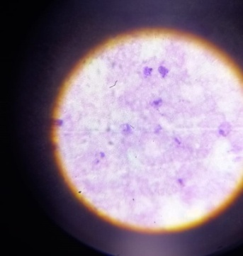
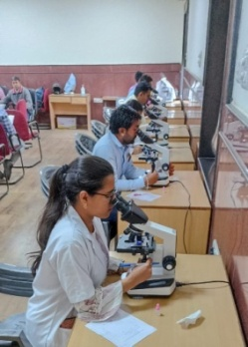
Laboratory Technicians training
With objective of imparting knowledge about Malaria under NVBDCP, laboratory technicians/Laboratory Assistants are trained at SIHFW in 5 days training. Make shift Laboratory equipped with microscopes is established in a training hall at SIHFW for this type of training. Participants are trained by Nodal Officer, Malaria programme (NVBDCP) and senior Laboratory technicians/ Lab assistants on appropriate sampling and diagnosis of Malaria. This is a hands-on skill development training.

State ToT on MNS, Elderly and Palliative Care
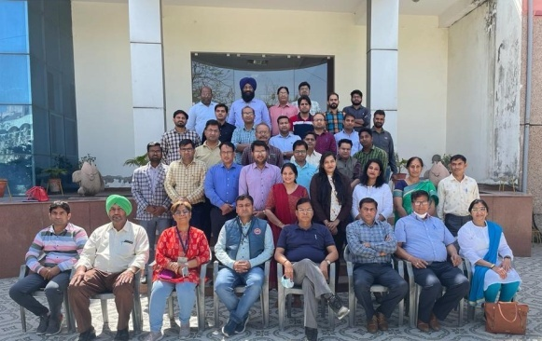
Under Health and Wellness Centre (HWC) component of NHM, a new programme has been introduced titled ‘Mental and Neurological Substance Abuse (MNS), Elderly and Palliative Care’. At initial stage, a 6 day State ToT was organized for state trainers of piloted 10 districts-Ajmer, Bhilwara, Bikaner, Churu, Dungarpur, Dholpur, Jodhpur, Sriganganagar, Nagaur and Udaipur. State ToT for these districts was organized at SIHFW during March 7 to 12, 2022. Master trainers for the ToT were Senior Professors from Centre of Palliative Care Medicine, SMS, Specialists from Bhagwan Mahaveer Cancer Research Centre, Psychiatry centre, SMS Medical College, Medical officers, Nursing tutors and SIHFW staff. Participants included Medical officers and Nursing tutors from the 10 pilot districts. Key highlight of this training was hands on practice centre and skill assessmsnets at the end of the training. Field visits were also organized for participants to observe cases and nursing care at Psychiatry centre, centre for palliative care medicine and cancer research centre. Till March 2022, 7 batches of District ToT were also organized.
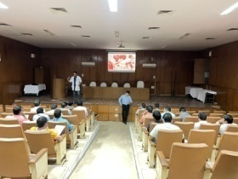
Training on Hemophilia and Hemoglobinopathy
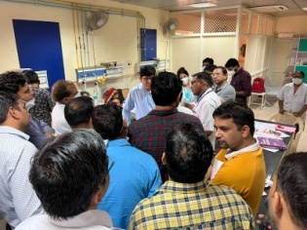
Hands on training on Hemophilia and Hemoglobinopathy was organized by SIHFW at JK Lone Hospital, Jaipur. The training was of 3 days and was organized during March 25 to 27, 2022. Participants were oriented on interpretation of CBC, management of haemophilia, Thalassemia and sickle cell diseases, approach to bleeding disorder were main contents of this training. The training also included real life case discussions on Hemophilia/ thalassemia/ hemoglobinopathy.
Training workshop on Viral Hepatitis
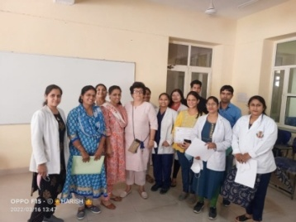
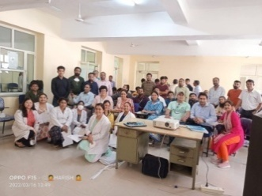
A 2 days training workshop on Viral Hepatitis was organized under National Viral Hepatitis Program with an objective to orient participants on laboratory diagnostics of various types of Hepatitis (HAV, HBV, HCVand HEV) and to make them capable of effectively delivering quality assured testing services. The training was orhganised on March 15-16, 2022 at SMS Medical College, Jaipur. Training included hands-on sessions on Laboratory Diagnosis of Hepatitis at Microbiology Department SMS hospital, March 15-16, 2022.
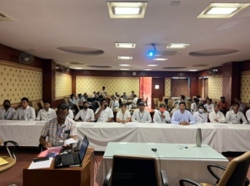
Quiz of ANM on March 30, 2022
A quiz competition for ANMTC and GNMTC students of Rajasthan, was organised at SIHFW on March 30, 2022.

Workshop of ASHA and ANM-Asha programme cell-ASHA Focus Group Discussions
With an objective to find out the challenges faced by ASHA in various activity and responsibilities, an FGD was organized at SIHFW. Few select ASHA and their supervisory staff participated in this FGD. The FGD was organized on March 14, 2022.
One day SIMS/SOCH software hands on training
This software based training was organized at SIHFW in computer lab. This is a one day hands on training for ICTC staff organized under RSACS. 5 batches of this training were organized during March 9 to 11 and March 14 & 15, 2022. The Strengthening Overall Care for HIV Patients (SOCH) software works for objective to create a beneficiary centric web and mobile based system, to track and record beneficiary services and inventory transaction in national HIV program with focus on improving service delivery and beneficiary health outcome.
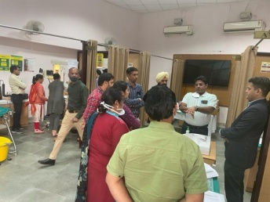
Dakshata ToT at SIHFW- March 7 to 11, 2022
The Initiative focuses on capacity building for supply side frontline workers, routine tracking of pregnant women to enable safe deliveries, analytical exercises to examine the causal factors and bottlenecks to efficient health service delivery, and effective decentralization in decision making which allows village level contextual needs to be translated to planning interventions at the Block and District level.

Dakshata is an initiative under the National Health Mission to improve the quality of maternal and newborn care during the intra- and immediate postpartum period, through providers who are competent and confident. The programme was launched in 2015. Trainings under this programme are organized by SIHFW on a regular basis. Medical officers and Nursing tutora participated in this training at SIHFW on March 7 to 11, 2022.
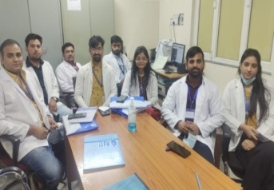
BEmOC Training at Gangouri Hosital, Jaipur March 21-30, 2022
Participants for this training are health care workers who are currently attending or will attend births in the acute phase of an emergency response. This includes midwives, nurses, general practice physicians, obstetricians/gynecologists, and others.
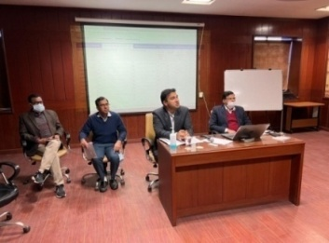
The content is based on the most recent clinical evidence by the World Health Organization (WHO) and IAWG’s 2018 Inter-Agency Field Manual for Reproductive Health in Humanitarian Settings. It covers the necessary skills and professional behaviors for handling common obstetric emergencies at multiple levels of care, including: postpartum infection, pre-eclampsia/eclampsia and postpartum hemorrhage. Elements of essential newborn care and newborn resuscitation are also covered in this course. SIHFW organizes this training at Hospitals where participants are given patient cases and hands on exposure.
Session of MD NHM in Training on IDSP
MD, NHM visited SIHFW in training on IDSP on January 4, 2022. Dy CMHOs, BCMOs, SMO, MOs, Data Managers from various districts participated in the training. Officials from IDSP Cell, DMHS were resource persons in this training.

Field Trainings
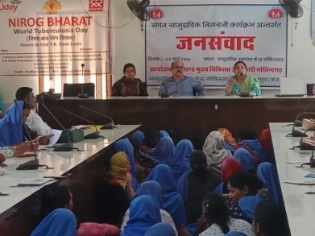
Jan Samvad organized by SIHFW
Jan Samvad is a tool under Community Action Process. Jan samvad were organized by SIHFW in coordination with district NHM teams. Objective of the Jan samvad is to take feedbacks from community on health programmes, schems and services or provisions for community, identify gaps and make solutions to improve upon the same , wither immediately or later on with interventions.
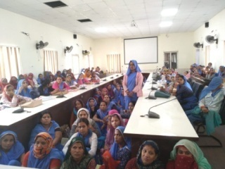
For process of Jan Samvad, NHM district staff were oriented on Jan Samvad tool and later Jan samvad were organized on districts at Block levels. At the initial stage community provided feedback on quality of health provisions in form of financial supports, or facility level and community level care, through field workers. For example, availability of euipments, supply, availability of health service providers, bahevaiour issues, financial support under schemes such as JSY, Rajshree Yojna, etc. In Jan samvad, a direct dialogue takes place between community and service providers/ administration. If possible, immediate remedial measures are taken, else gaps identified by the community are documented, further explored and procedural decisions are taken such as HR, supply of drugs, etc. Dr Rajni participated and facilitated Jan samvad at Govondgarh block of Jaipur district on 23 March 2022.
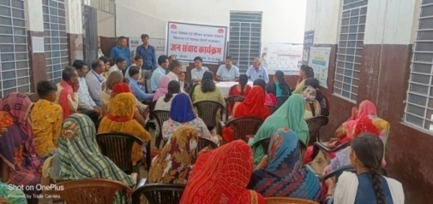
Till March 2022, 44 Jan samvad were organized by SIHFW in 11 districts. 4 Jan samvad were organized in every district.
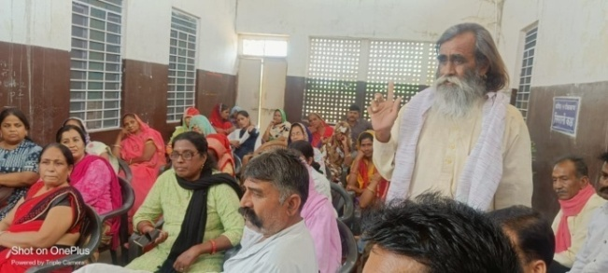

Research Study

Research study titled “GIS mapping of Ultrasound Clinics registered under PC & PNDT Act in Rajasthan and mapping of Districts, Blocks with low sex ratio and availability of diagnostic centers in their vicinity” has completed the data collection part as per the planned schedule, by March 2022. Data collected though app is now under analysis.

Health News

Unhealthy Diet may Lead to Non-communicable Diseases

India's largest primary healthcare survey report titled "Non-Communicable Diseases in India" on the rising burden of non-communicable diseases (NCDs) in the country has been released as a part of ASSOCHAM' 'Illness to Wellness' campaign. The report covered 2,33,672 people and 673 public health offices across 21 states. It concluded that an imbalanced diet is amongst the top three causes for the high rate of NCDs in India.

The study found that people were increasingly consuming diets low in legumes, milk, omega-3 fatty acids, vegetables, fruits, calcium, etc, and were opting for foods rich in sugar and trans-fats. The most common NCDs due to consumption of unhealthy diet included hypertension, digestive diseases, and diabetes. The prevalence of NCDs in India was found to be 116 per 1000 population.
"In today's times, optimum nutrition is truly medicinal," said Dr. Zubeda Tumbi (PhD Nutrition), Founder, HealthWatch Nutrition, Senior Clinical Nutritionist, Expertise in Weight Management & Metabolic Diseases, Certified Diabetes Educator, IBS FOD map certified in her special address. She went on to say that switching to functional foods for therapy to protect, reverse, or remove an ongoing condition can assist relieve mental, economic, and financial stress.
Anil Rajput, Chairperson, ASSOCHAM CSR Council shared that issues related to our diet, weight, and physical activity are the biggest public health challenges we are facing in current times. Even though our policymakers are taking significant steps to inculcate a healthy food culture through interventions such as 'The Eat Right Movement', 'Task Force on Balanced and Healthy Diets', 'Poshan Abhiyan' among others, sustained action from all stakeholders will be critical to identify strategies for the promotion of wholesome and healthful diet across all sections of the society.
A balanced diet is a means to keep yourself fit and active, according to Dr. Shabana Parveen, Group Team Leader, Clinical Nutritionist Clinical Nutrition & Dietetics Department Artemis Hospitals, Gurugram. A healthy diet enhances body performance, strengthens your immune system, and protects you from diseases like diabetes, high blood pressure, heart disease, stroke, and others.
Eat a variety of meals, such as whole-grain cereals, ragi, bajra, jowar, entire legumes, beans, whole pulses, healthy fats, fruits, and vegetables, to get a wide range of nutrients. She added, It's vital to eat a varied diet rather than relying on a single nutrient and all nutrients are necessary for performing bodily functions effectively. She was advised to stay hydrated and active at all times. Vinita Aran, Senior Nutritionist, Wellness Coach at Apollo Clinic, Andheri (E) Founder of Diet Clinic 'Eat your way to good health' shared her insights saying that people are forgetting about traditional and seasonal foods available in India which are a great source of nutrients. She said to include whole foods and nutrient-dense in our diet for extra benefits. Source: MedIndia, News/ 28.3.2022

Effect of Low-Birth Weight on Cognitive Development of Children in India

Does birthweight affect cognitive outcomes? Yes, reveals a new study conducted among the children in India. Low birth weight (LBW), referring to infants weighing less than 2,500 grams at birth, is a significant public health issue in resource-poor countries. Each year, around 20.5 million newborns, an estimated 15-20% of all infants born globally are LBW.

Previous studies show that LBW infants have a higher mortality risk in their first month of life while those who survive infancy face worse health, human capital, IQ, and labor market outcomes. An estimated 18% of Indian infants are LBW.

CDDEP researchers along with collaborators at Sam Houston University, International Institute for Population Sciences (IIPS) employed instrumental variable regression models with longitudinal data from the Indian Young Lives survey (YL) survey in Andhra Pradesh to estimate the effect of birth weight on cognitive development during childhood in India. Although there is considerable research on the effects of LBW on outcomes in adulthood, there is limited evidence linking LBW with mid-childhood outcomes through which the adult outcomes manifest.
Mid-childhood outcomes are more amenable to policy interventions than adverse outcomes in adulthood. This is the first study we are aware of that estimates the effects of birthweight on cognitive outcomes in the mid-childhood years (5-8 years) of children in India.
The authors estimate the causal effect of birth weight on children's Peabody Picture Vocabulary Test (PPVT) score, a measure of cognitive ability and they examine the heterogeneity in the effects of birth weight by socioeconomic characteristics of participants' households. Overall, the study found that:
- A 10 percent increase in birth weight increases cognitive test scores by 0.11 standard deviations at ages 5-8 years.
- LBW infants experienced lower test scores compared with normal birth weight infants.
- The positive effect of birth weight on a cognitive test score is larger for girls, children from rural households, and those with less-educated mothers.
- Health policy must be designed to improve neonatal outcomes in India and other LMICs, with policies and initiative that promote access to prenatal care and maternal nutrition to reduce the risk of LBW.
According to study co-author, Dr. Ramanan Laxminarayan, Director, CDDEP, "India has the largest birth cohort in the world. The 26 million children born each year represent a significant opportunity for economic growth. However, poor nourishment of mothers results in low birth weight infants, and is likely to result in large numbers of children who are disadvantaged from the outset. This study should be a warning call to improve maternal nutrition." 'Birth Weight and Cognitive Development during Childhood: Evidence from India' is published in Economic Papers. Source: MedIndia, News/ 29.3.2022

Rajasthan government proposes 'Right to Health Care Act'
The denial of health care services in any health care facility will be fined up to Rs 10,000 from now in Rajasthan. The recent provision has been made in the proposed 'Right to Health Care Act'. The draft of the act is ready and the government has sought suggestions on the draft till March 24th.

The preamble of the Act says ‘to provide protection and fulfilment of rights equity in relation to health and well being for achieving the goal of health care for all through guaranteed access to quality health care to all residents of the state without any catastrophic out of the expenditure. And whereas the presenting inequitable accessibility and denials in the matter of health care in the state are a concern to all.’

The act provides many rights and duties of the residents and health care providers and obligations of the government. It gives the right to have free health care in government hospitals and in private hospitals that are established through the land allocation on concessional rates. The act also gives the right to family members of the deceased to receive the dead body irrespective of payment due status from every health care facility. The act also made it mandatory for the government to provide an appropriate state budget for the health sector and within six months of the enactment, develop and institutionalize a Human Resources Policy for health. The enactment of the act will be monitored by a State Health Authority, State Executive Committee and District Health Authority. Notably, Rajasthan’s Honourable CM Shri Ashok Gehlot had announced this Act in the budget of 2021 and to fulfil the announcement, the draft has been made public for the suggestions of citizens and other stakeholders. Source: The Free Press Journal, 20.3.2022

We solicit your feedback:
State Institute of Health & Family Welfare
Jhalana Institutional Area, South of Doordarshan Kendra Jaipur (Raj)
Phone-2706496, 2701938, Fax- 2706534
E-mail:-sihfwraj@ymail.com; Website: www.sihfwrajasthan.com

